

**Student Name:** Adeeb Shaban.

**HTU Course Number and Title:** 10202112 / Networking.

**Assignment Author / Course Tutor: Eng. Moath Sulaiman.**

**Assignment Title:**

**Ministry of Health Computer Network**



**To design a Local Area Network:**

We need to know what devices, topologies, protocols and servers we need to use.

We start by putting switches to connect pcs together because the maximum ports for each router is 4 so we need switches connected to routers to connect pcs and printers. Each router has an IP address, subnet mask. We used 2 servers in Amman by 4 services: DHCP, DNS, POP3, HTTP. We gave each server static IPs: 192.168.10.2, 192.168.10.3 with the default gateway for the servers 192.168.10.1.

For the justification of LANS, for example: In Mafraq, Tafilah and Irbid, we connected the Pcs and a printer for each governorate with switches and we used Ethernet cables. And in Amman we used 4 switches and printers regarding on the information bellow in the project and because this will have made the system simpler and not complicated.

I used the DHCP for we have huge number of computers and it is not easy to give all of them static IPs and because of that we used the DHCP server to give the computers automatic IPs. Also the DHCP pools will be implemented to the network, which are 192.168.10.0, 192.168.20.0, 192.168.30.0, 192.168.40.0, 192.168.50.0, 192.168.60.0, 192.168.70.0, 192.168.80.0.

I used the DNS so we can give some of the computers or servers a name instead of an IP to access that devices.

I used the HTTP so the people can access our services (MoH PROJECT) easily and given the URL [www.moh.gov.jo](http://www.moh.gov.jo) and this name is saved inside the DNS server.

And for the test plan:

First step is to test routers if they are getting accessed to, after configuring it, we use a laptop to ping and get access to the router and see its response. After testing, the expectations will be that we need to get a full response from the router or sending any data. That means that there’s a conflict between the IPs or a miss configuration in the router.

Next step, we need to test connection tools such as; Ethernet cables, switches and to check if each port of the switches is active using cable tester device and I expect that there is no issue with the switches.

Then, we check the servers to see if all the DHCP pools are given to the designated computers and by that we will know that the DHCP servers is working perfectly. And my expectations, is all the devices get their own IP address depends on what pool range we gave them.

Then, we tried to get access to HTTP websites by any end device. For example; for our project (MoH project), we wrote <http://www.moh.jo>. And my expectations that we got access to the website we need without delays.

And for the maintenance schedule, we need to know why we need maintenance for the networking system and how would we do that. Firstly, we need to check on the computers, servers and routers once every week so we need to check on the cables of the computers are connected or not damaged and if the computers need updates. Also for the servers, we need to check on the server components. Routers we need to check on the configurations of the routers and if they are not touched by anyone.

Here are some screenshots for the ping testing and the DHCP request.

**Ping from Amman to all:**

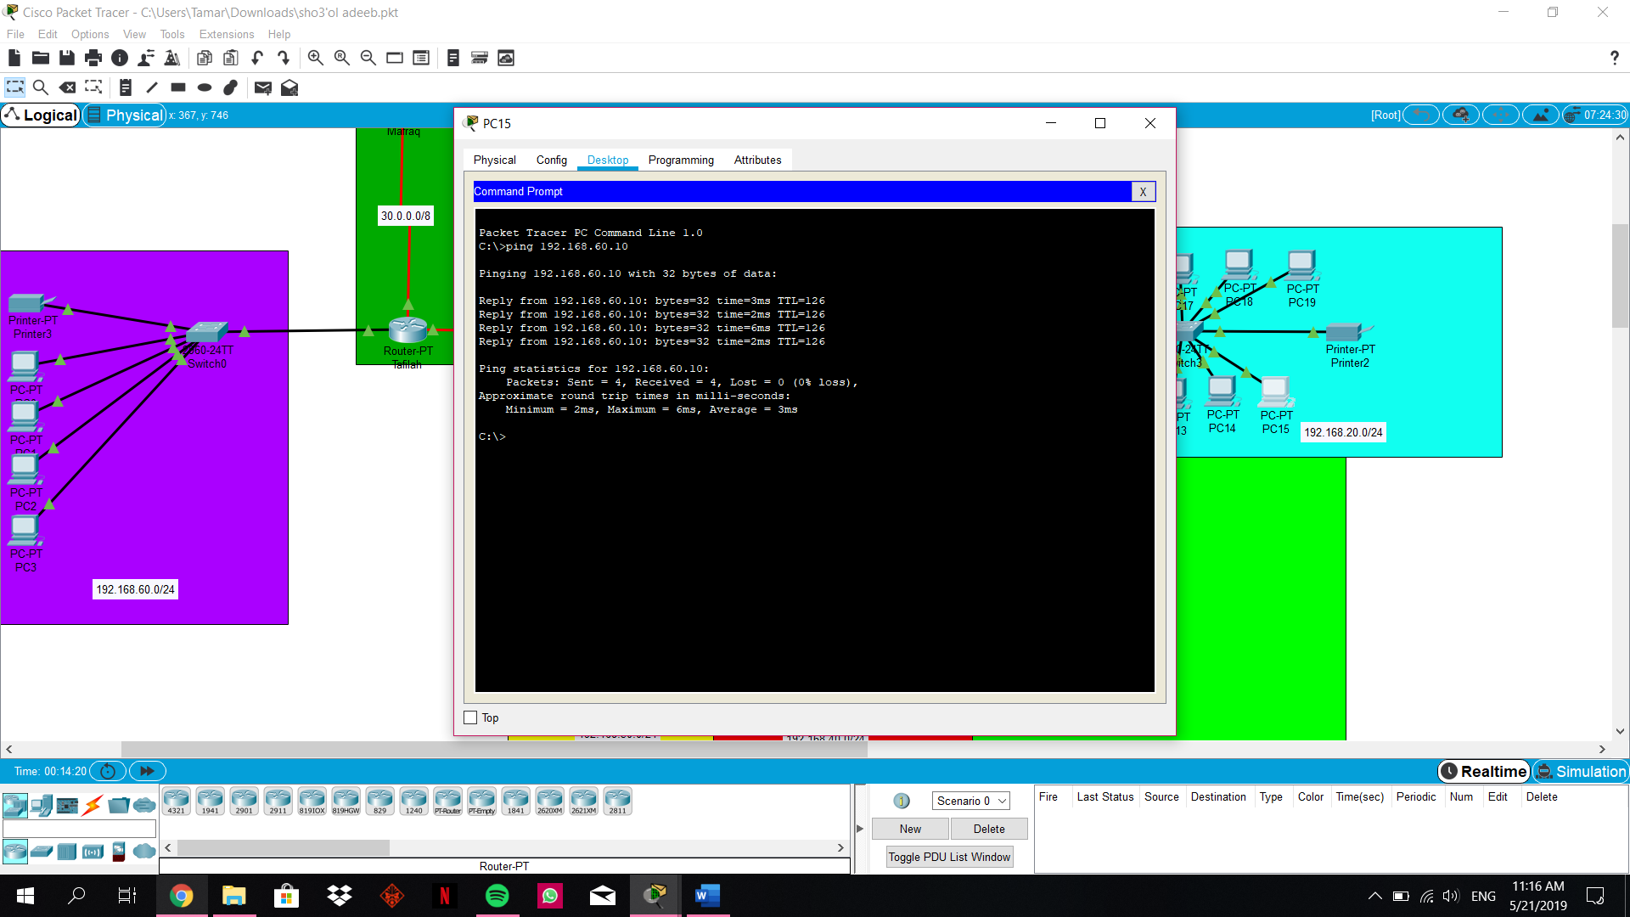

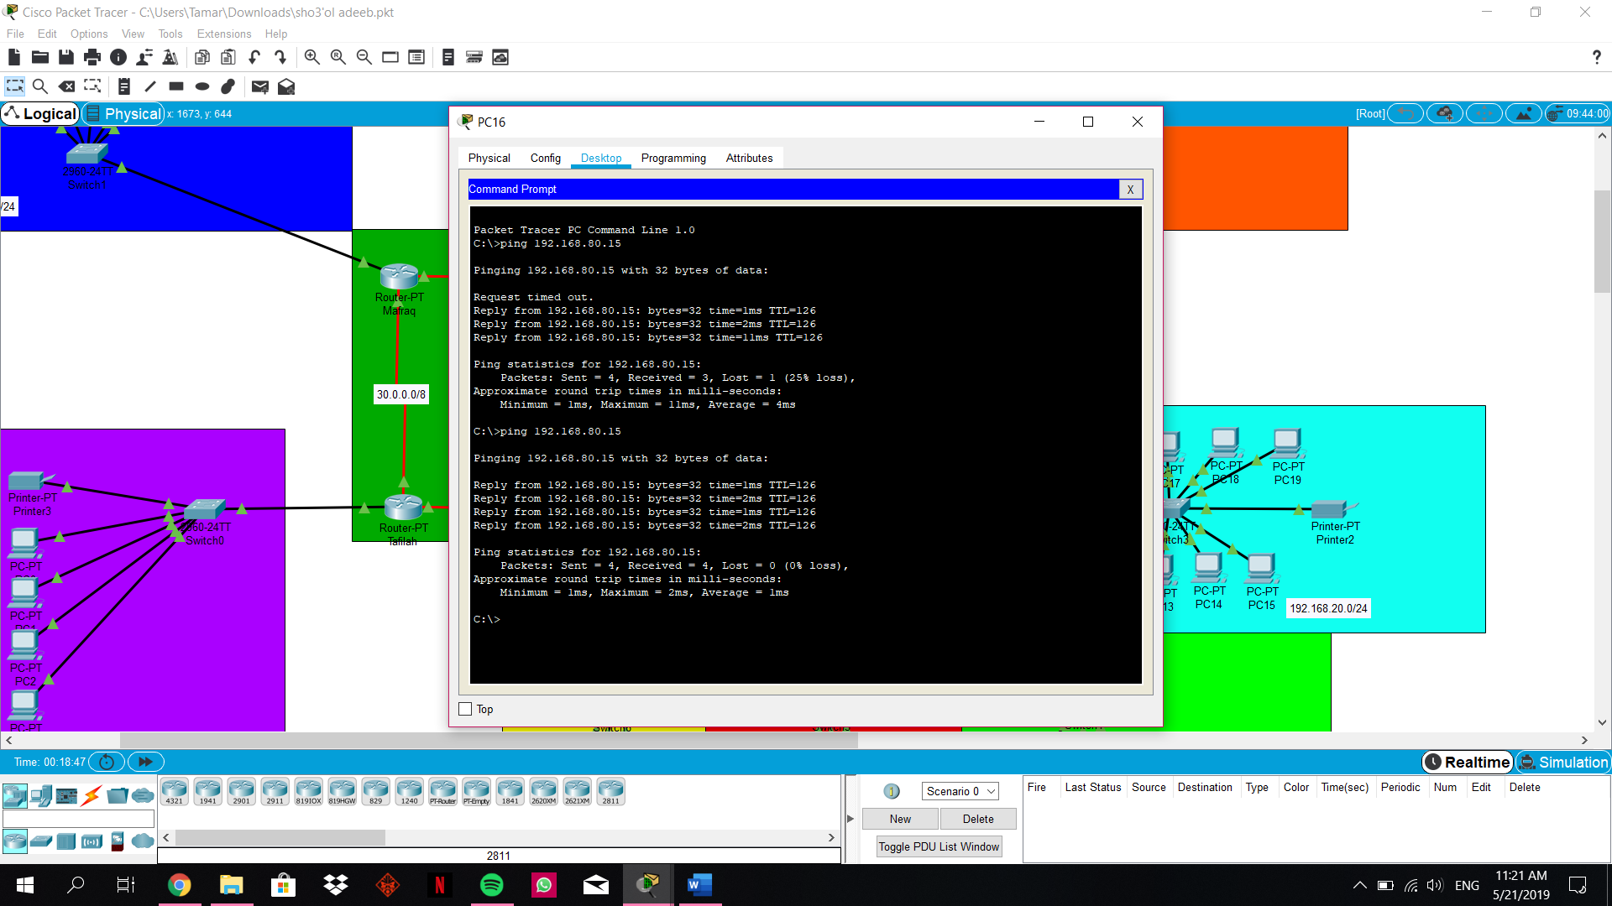

**Ping from Tafilah to all:**

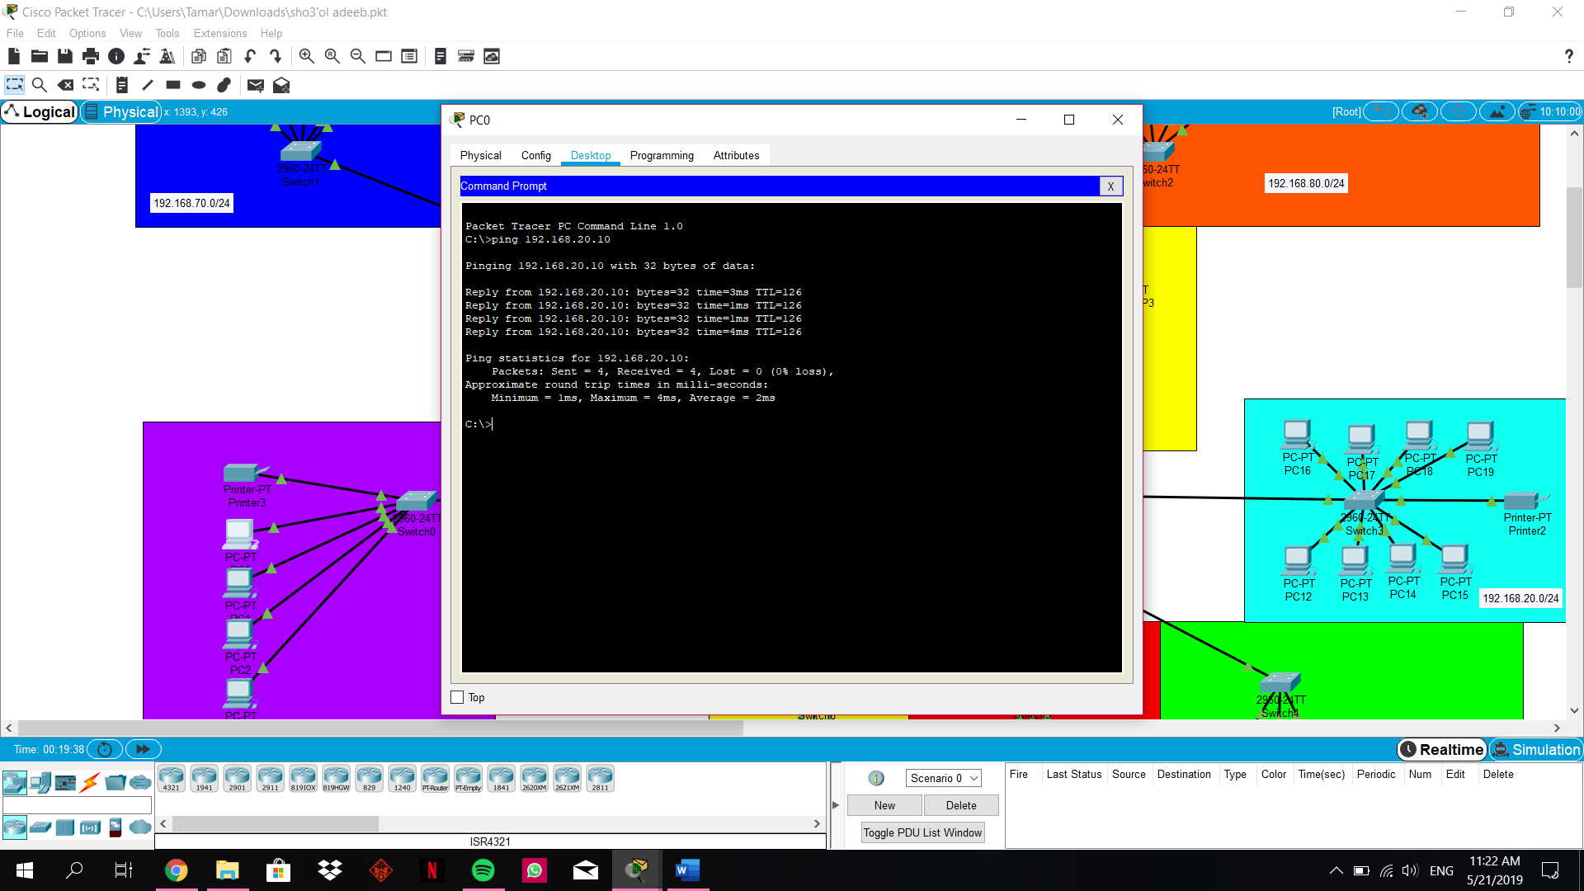

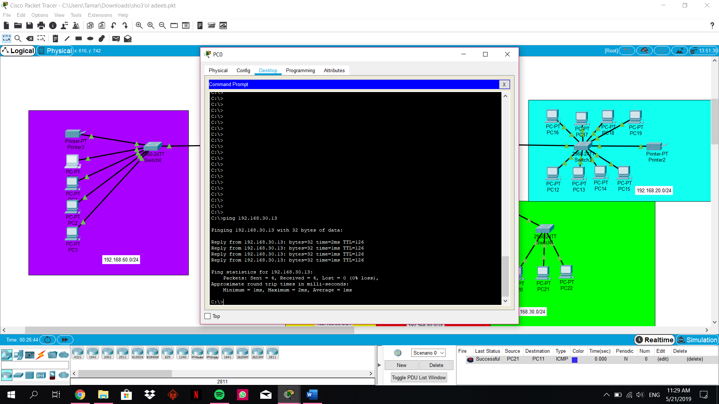

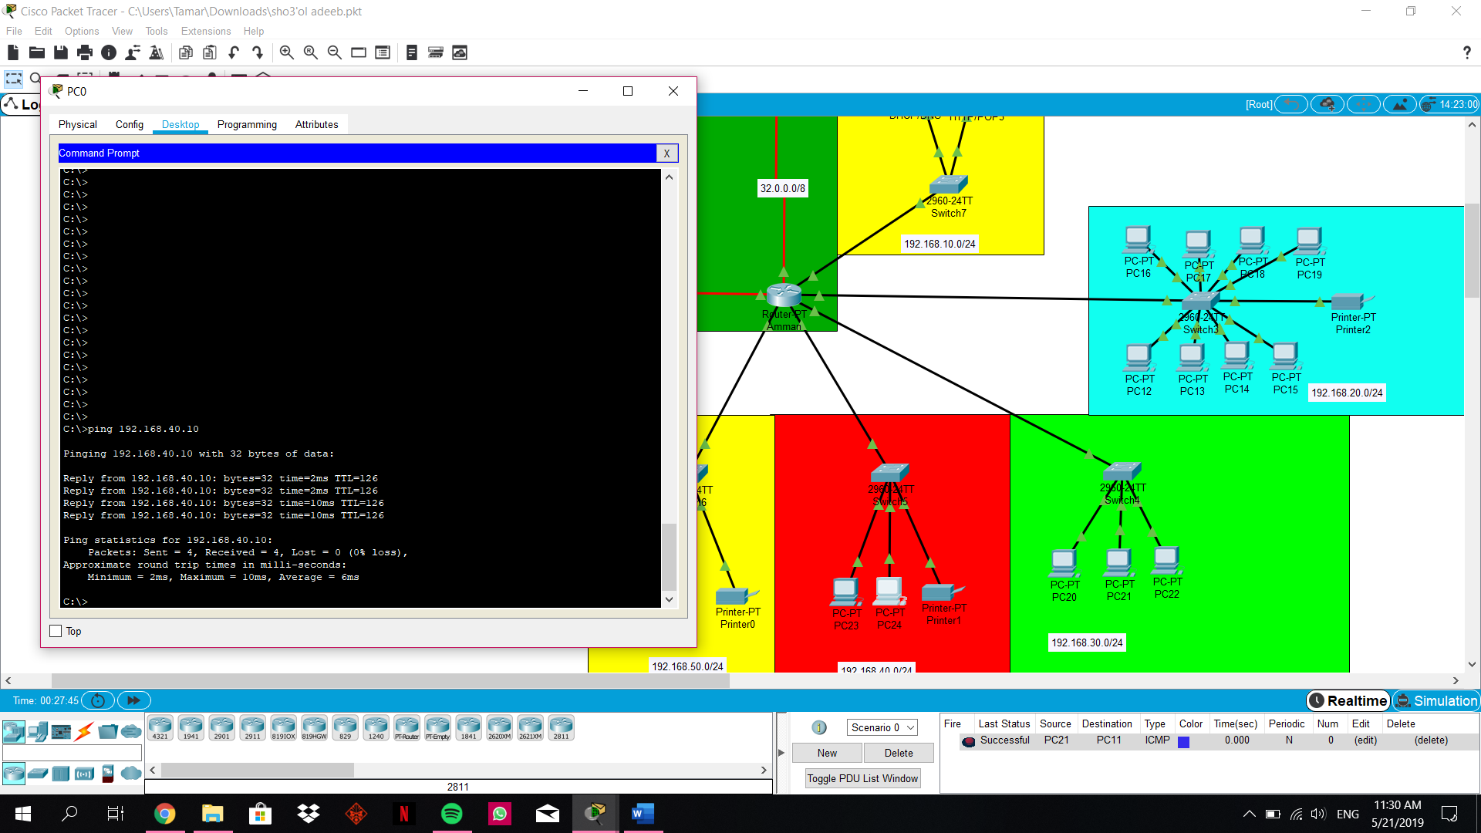

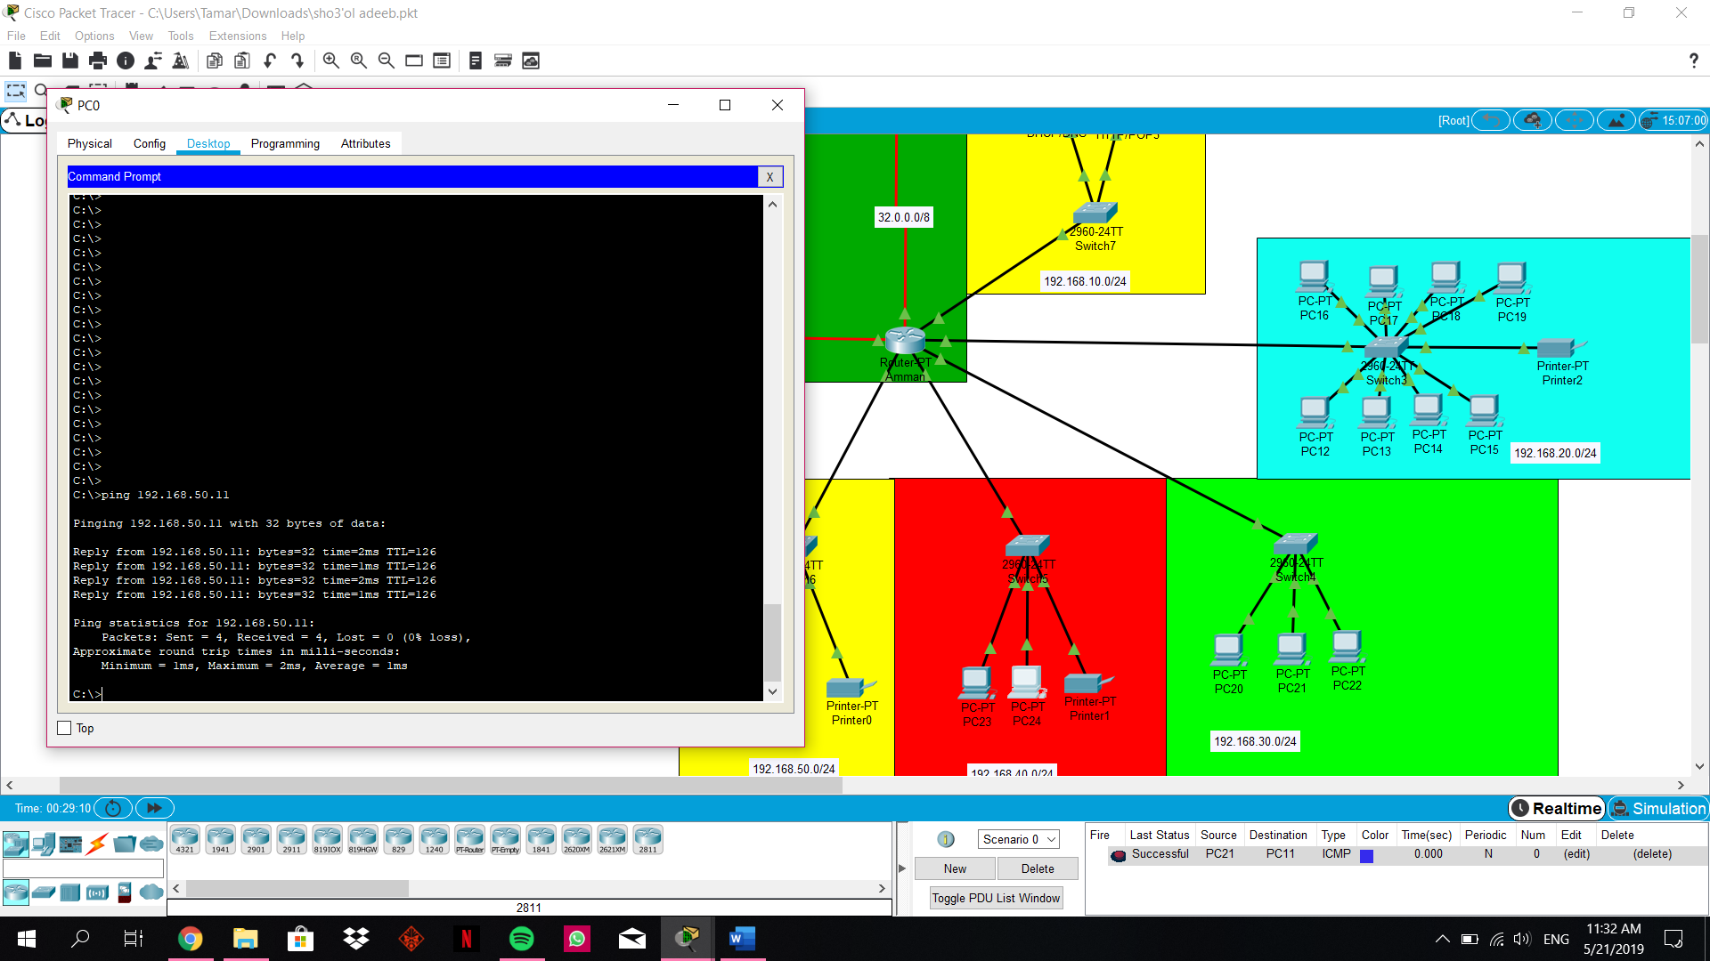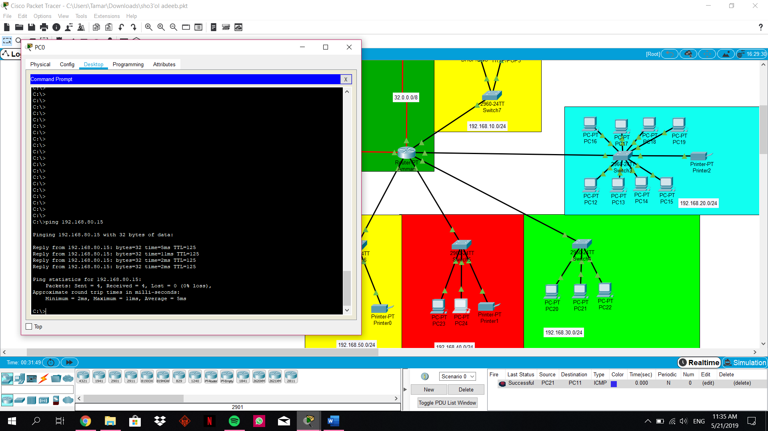

**Ping from Tafilah to all:**

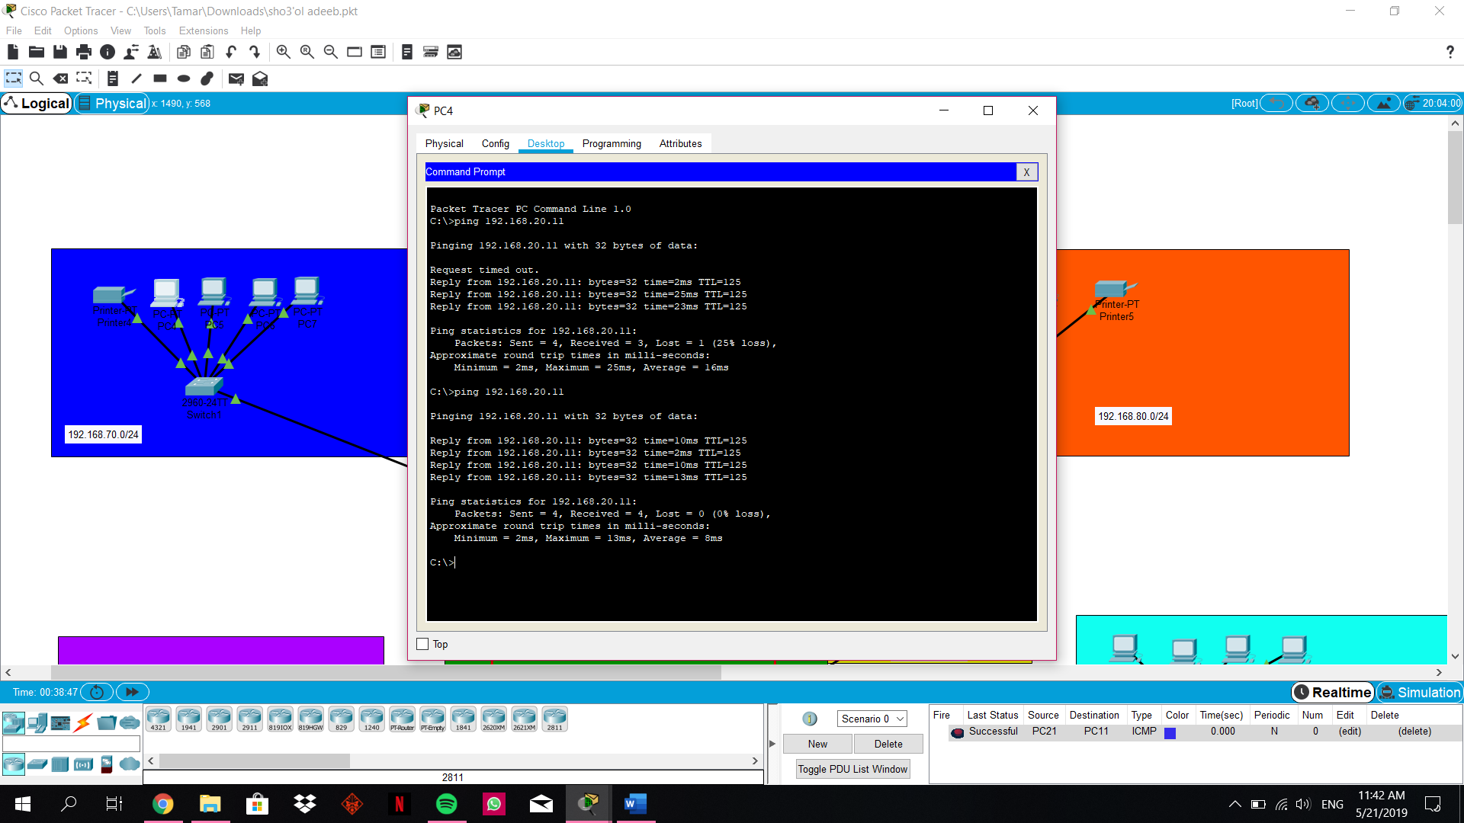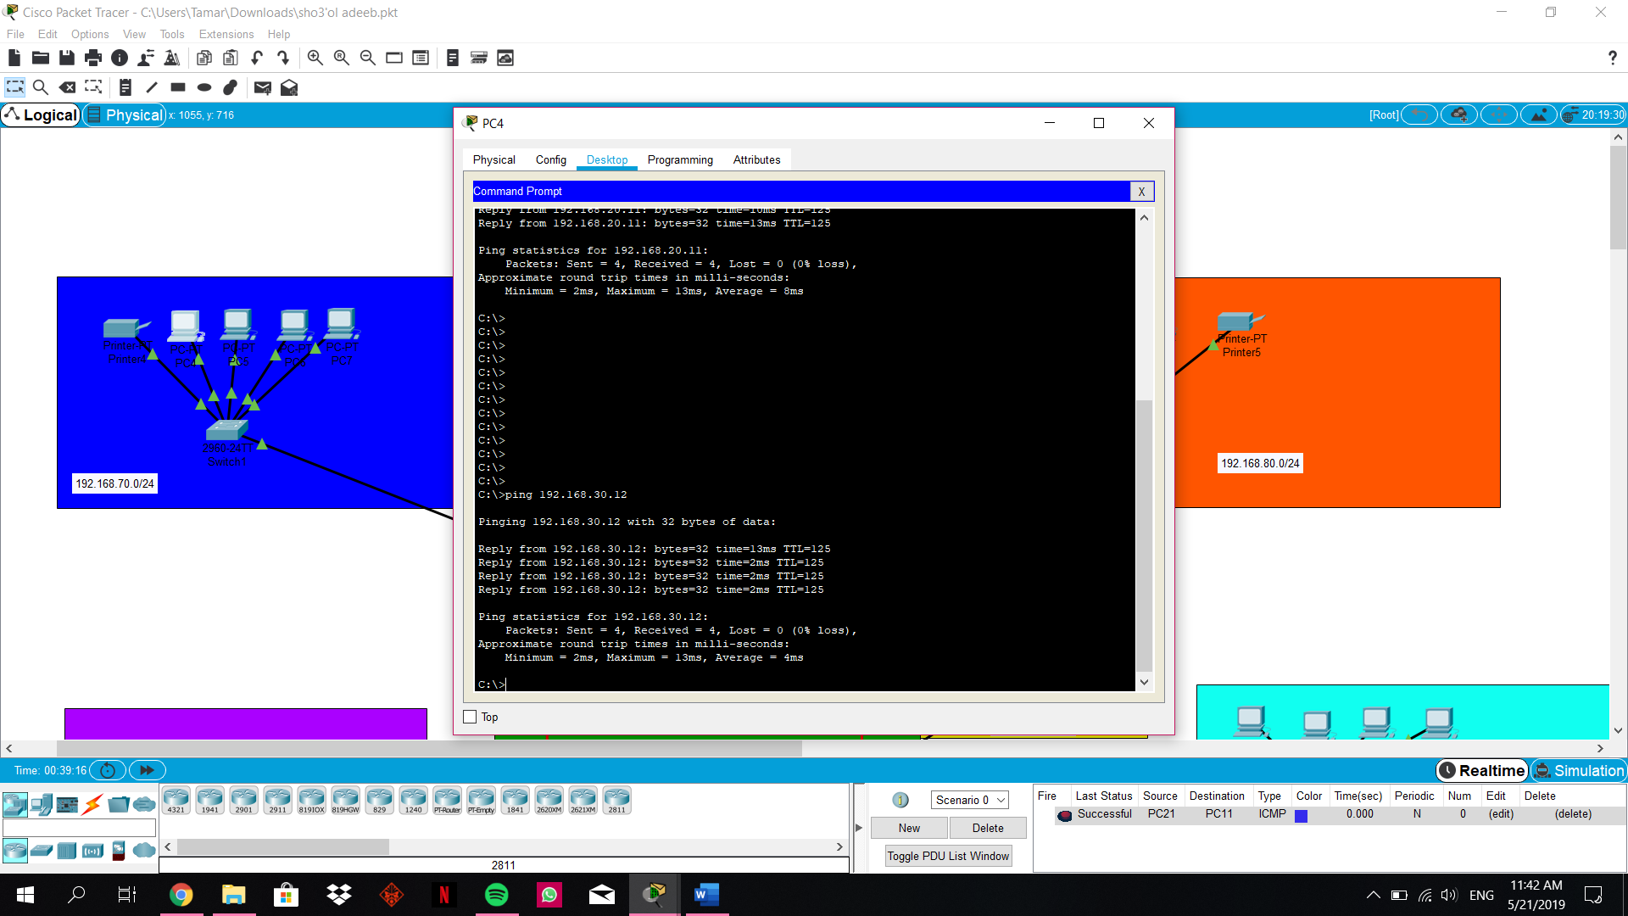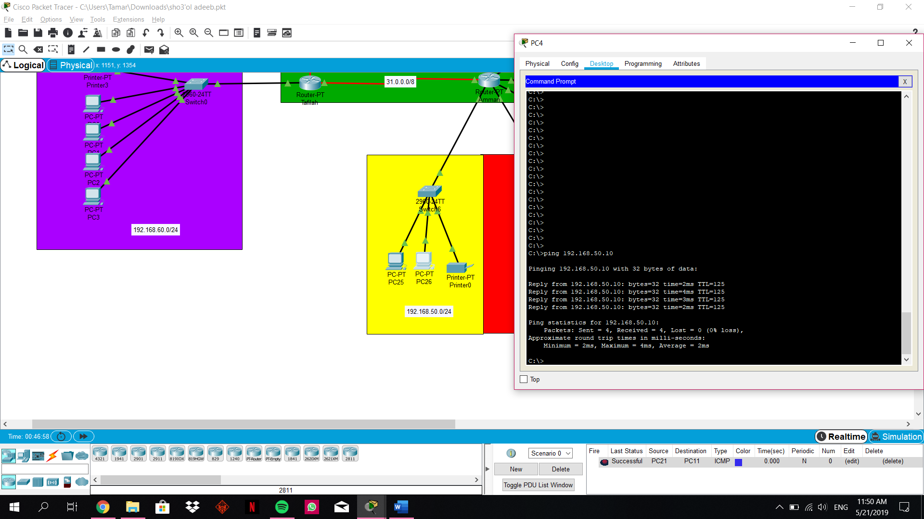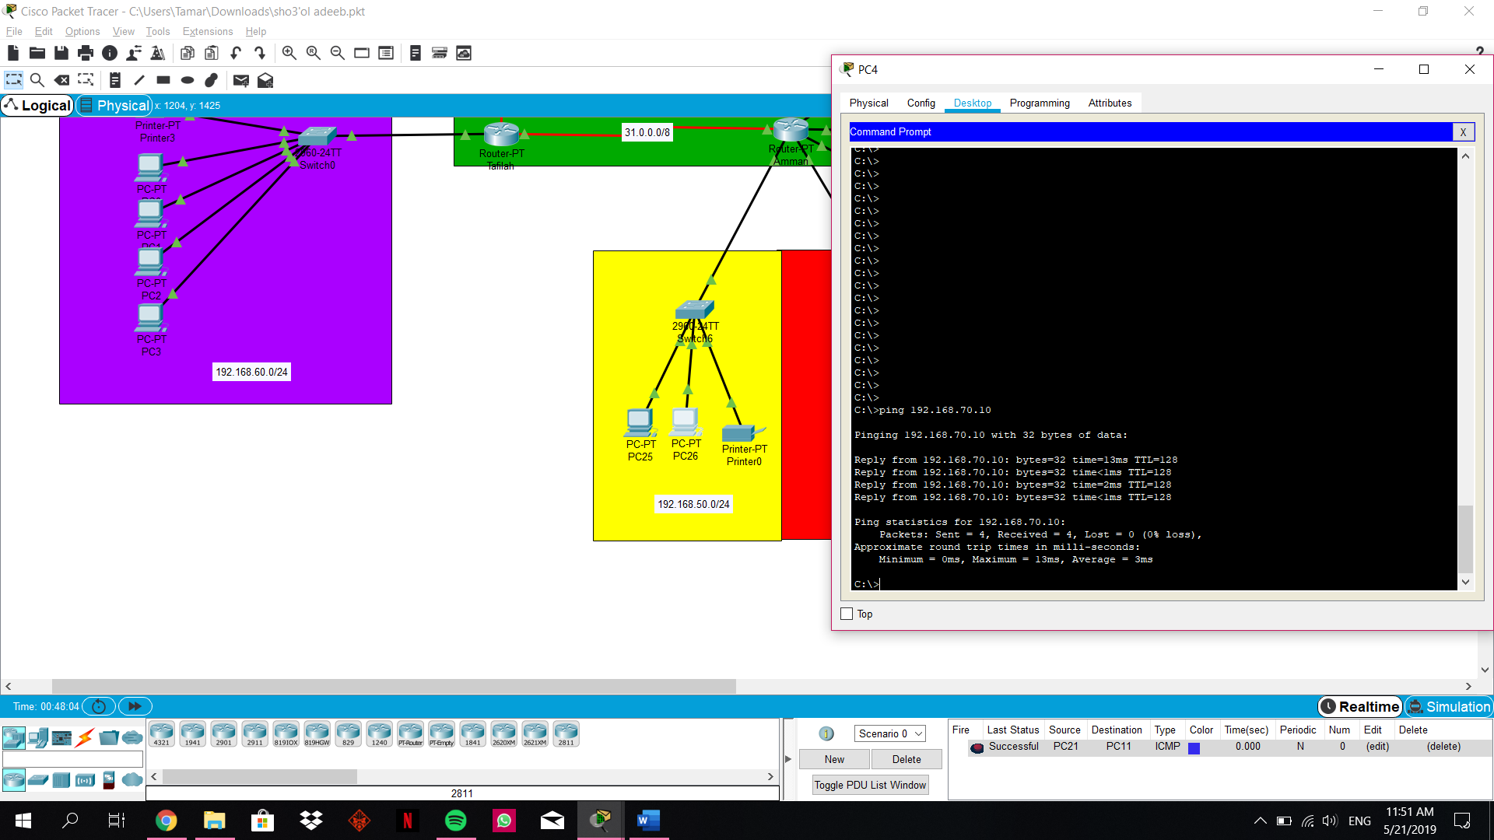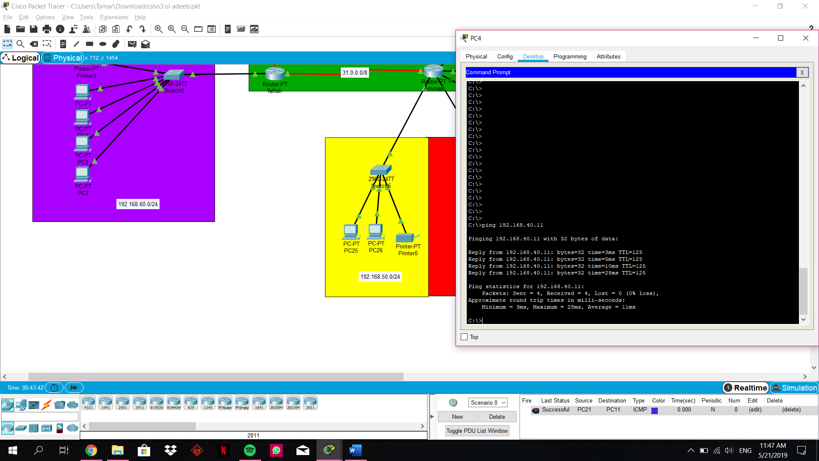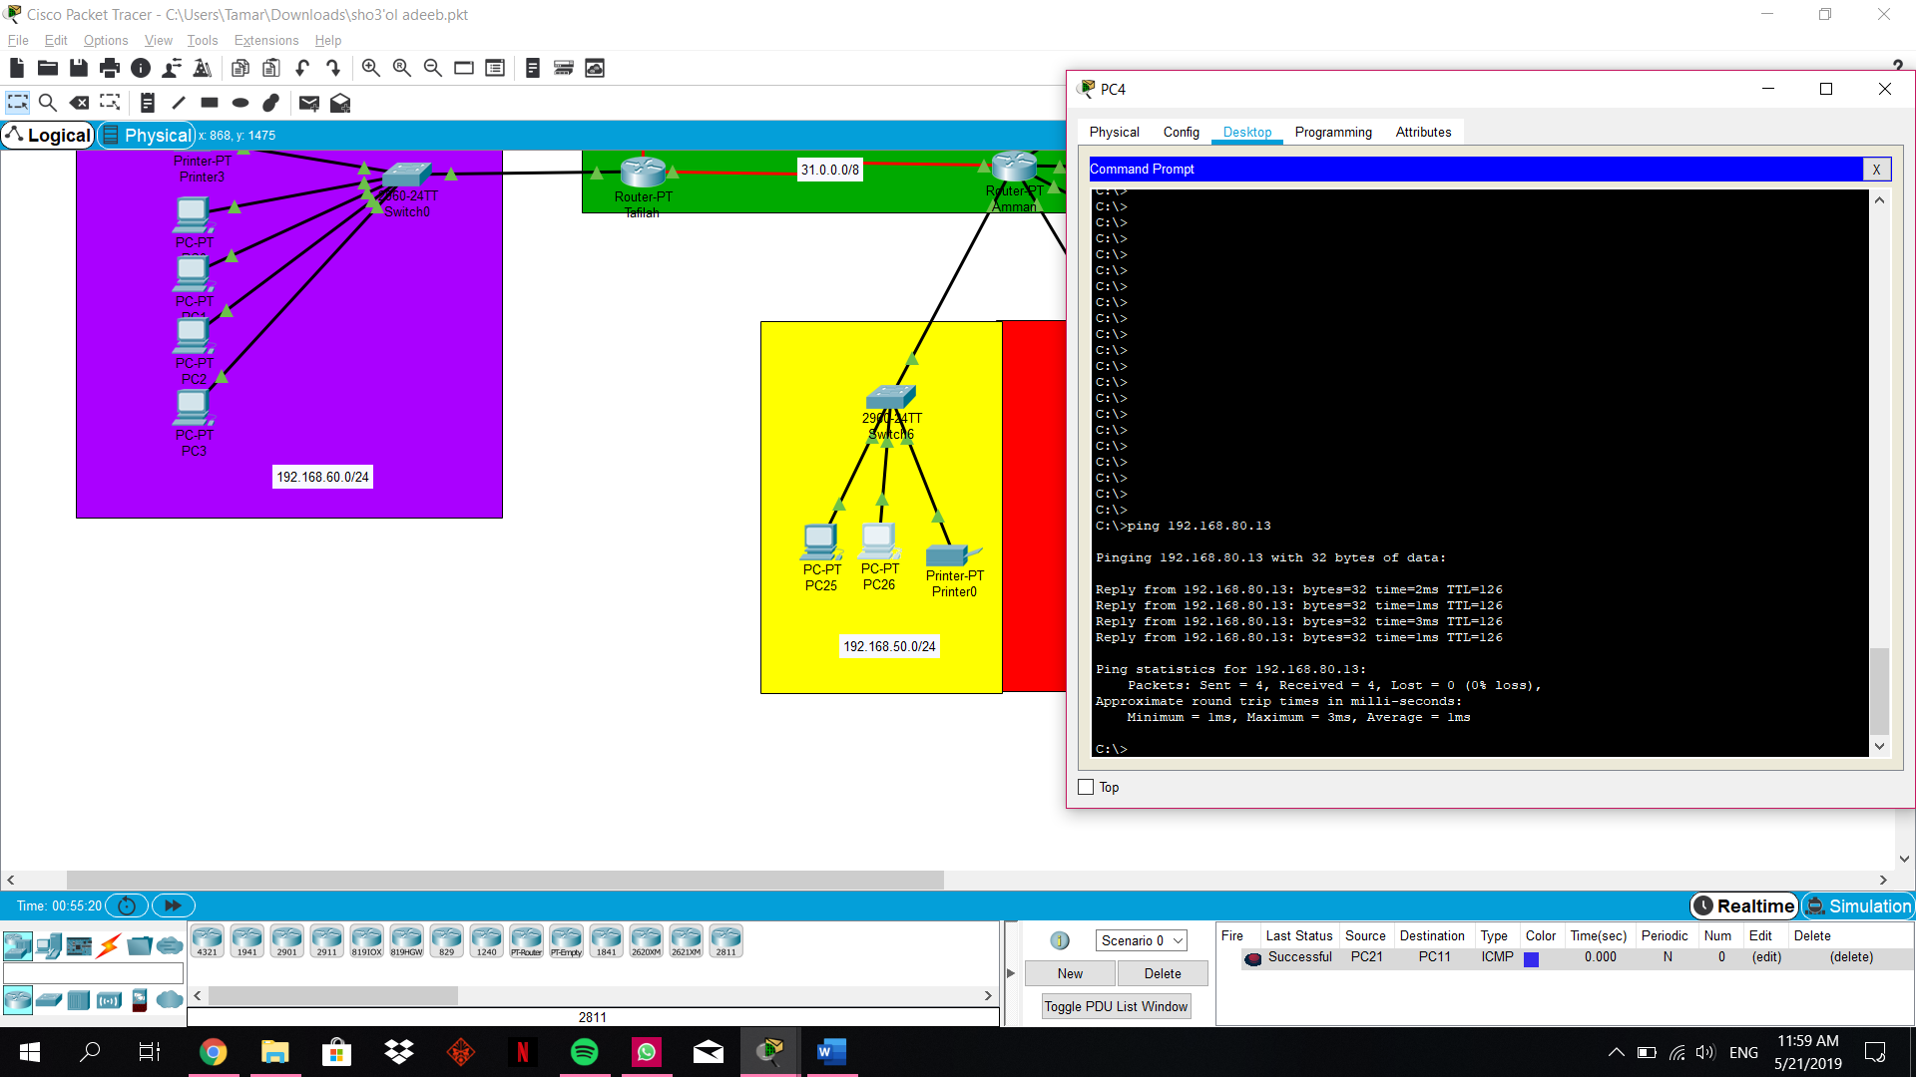

**Ping from Irbid to all:**

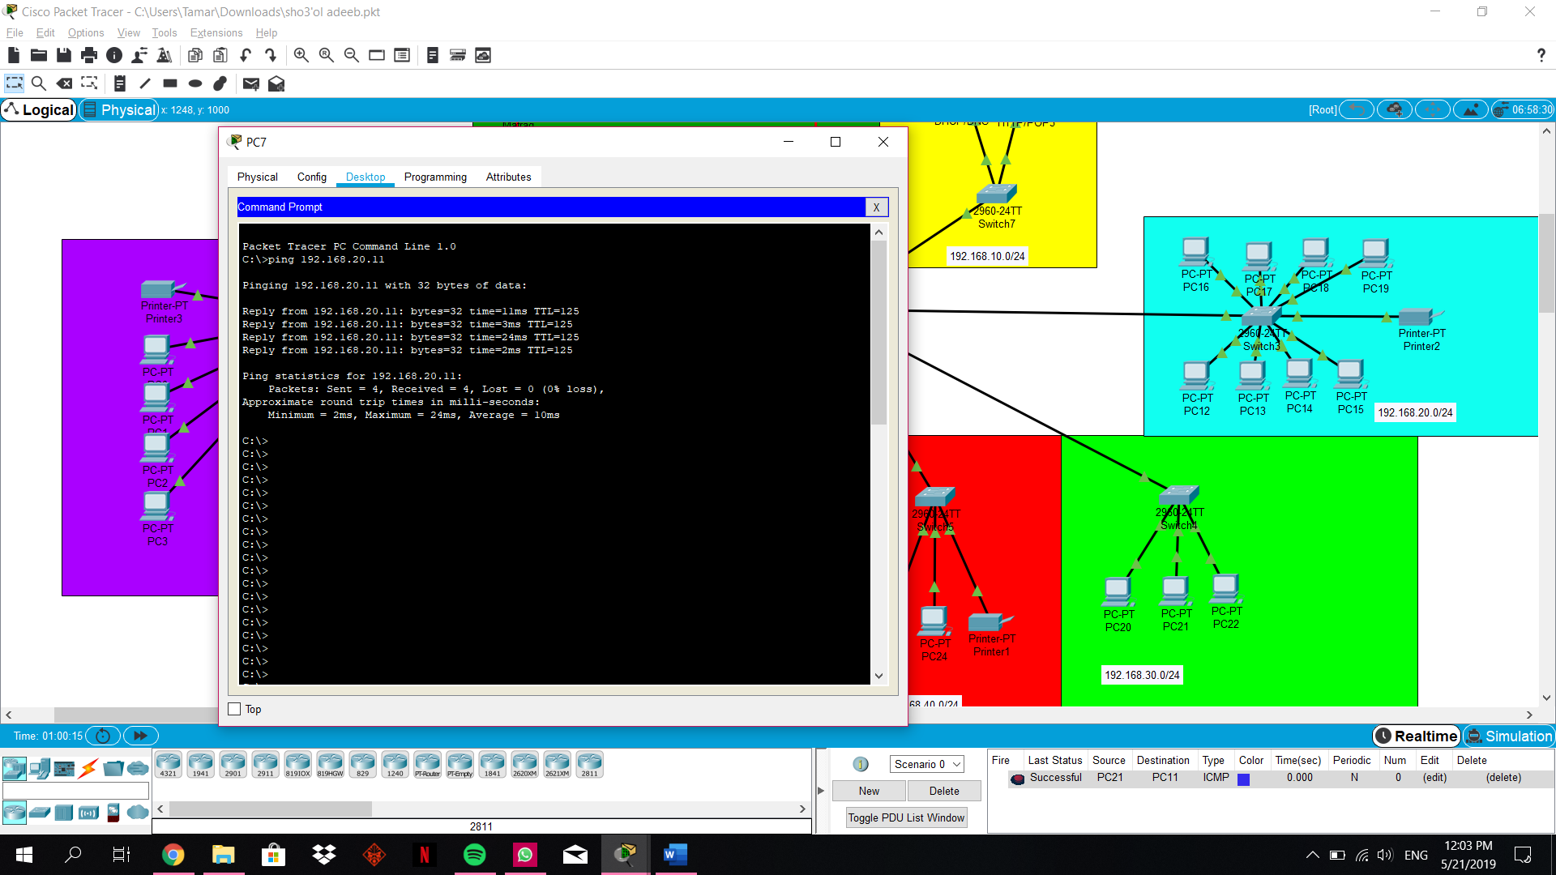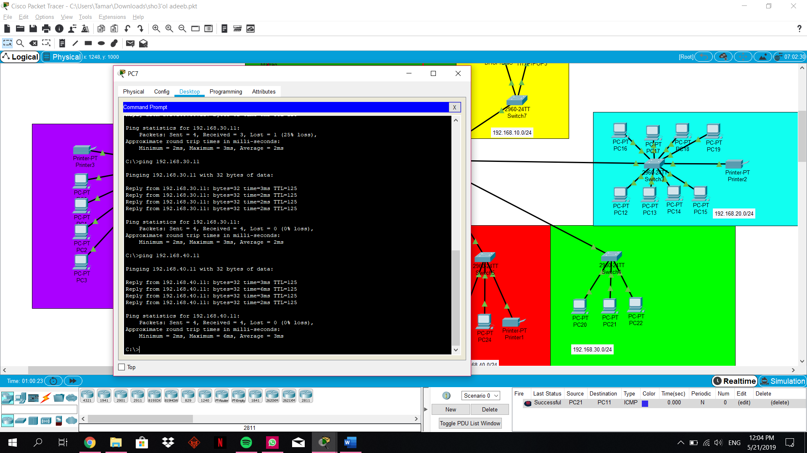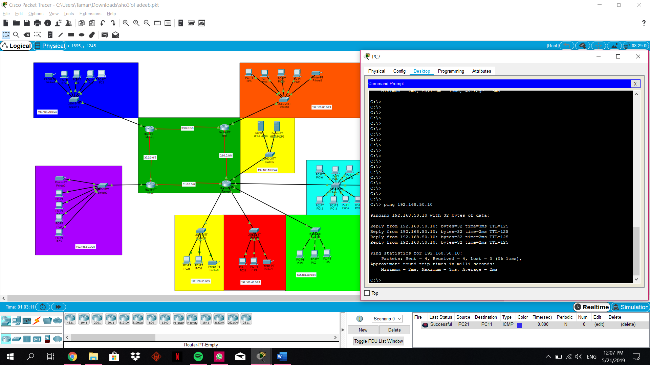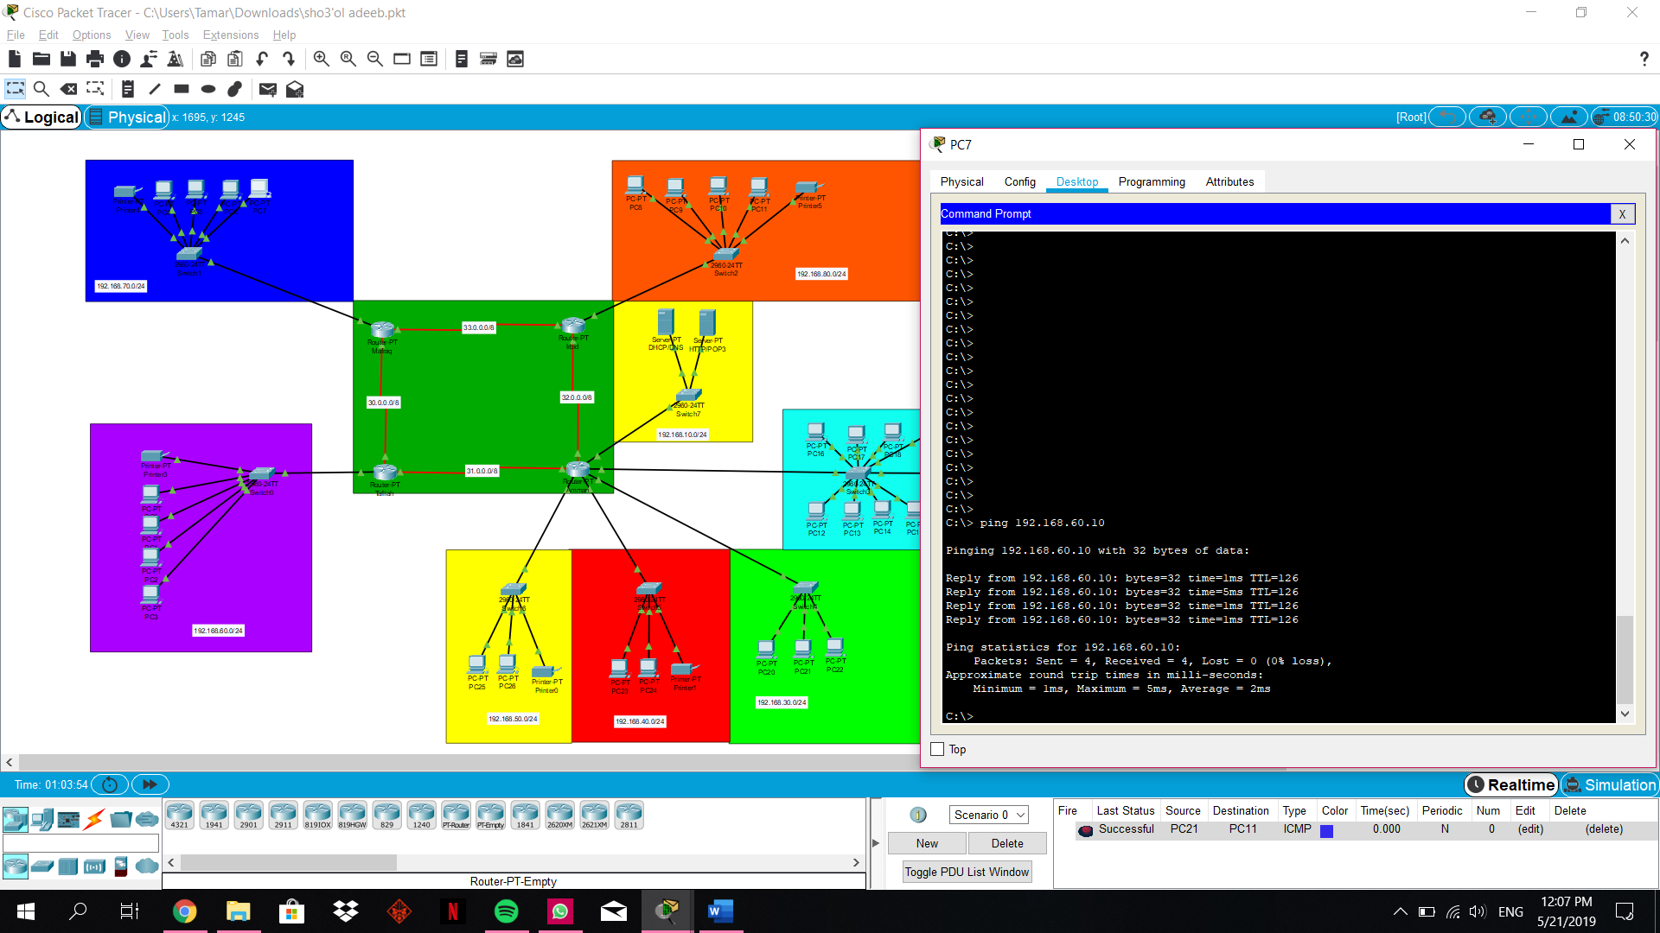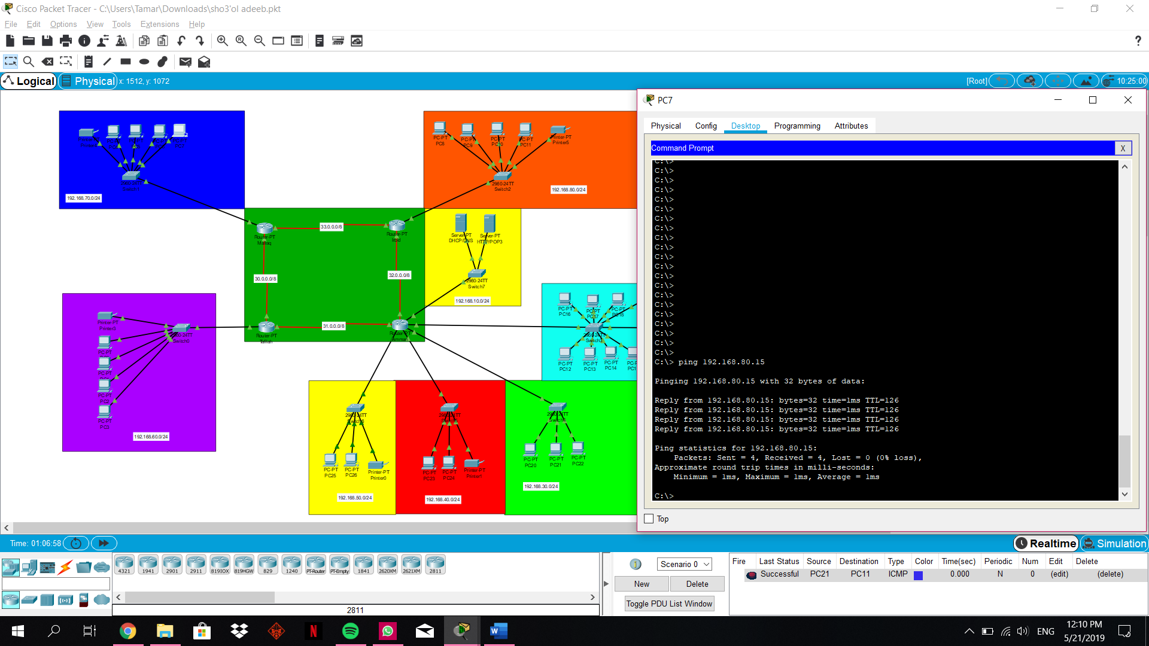

**Ping from irbid to all:**

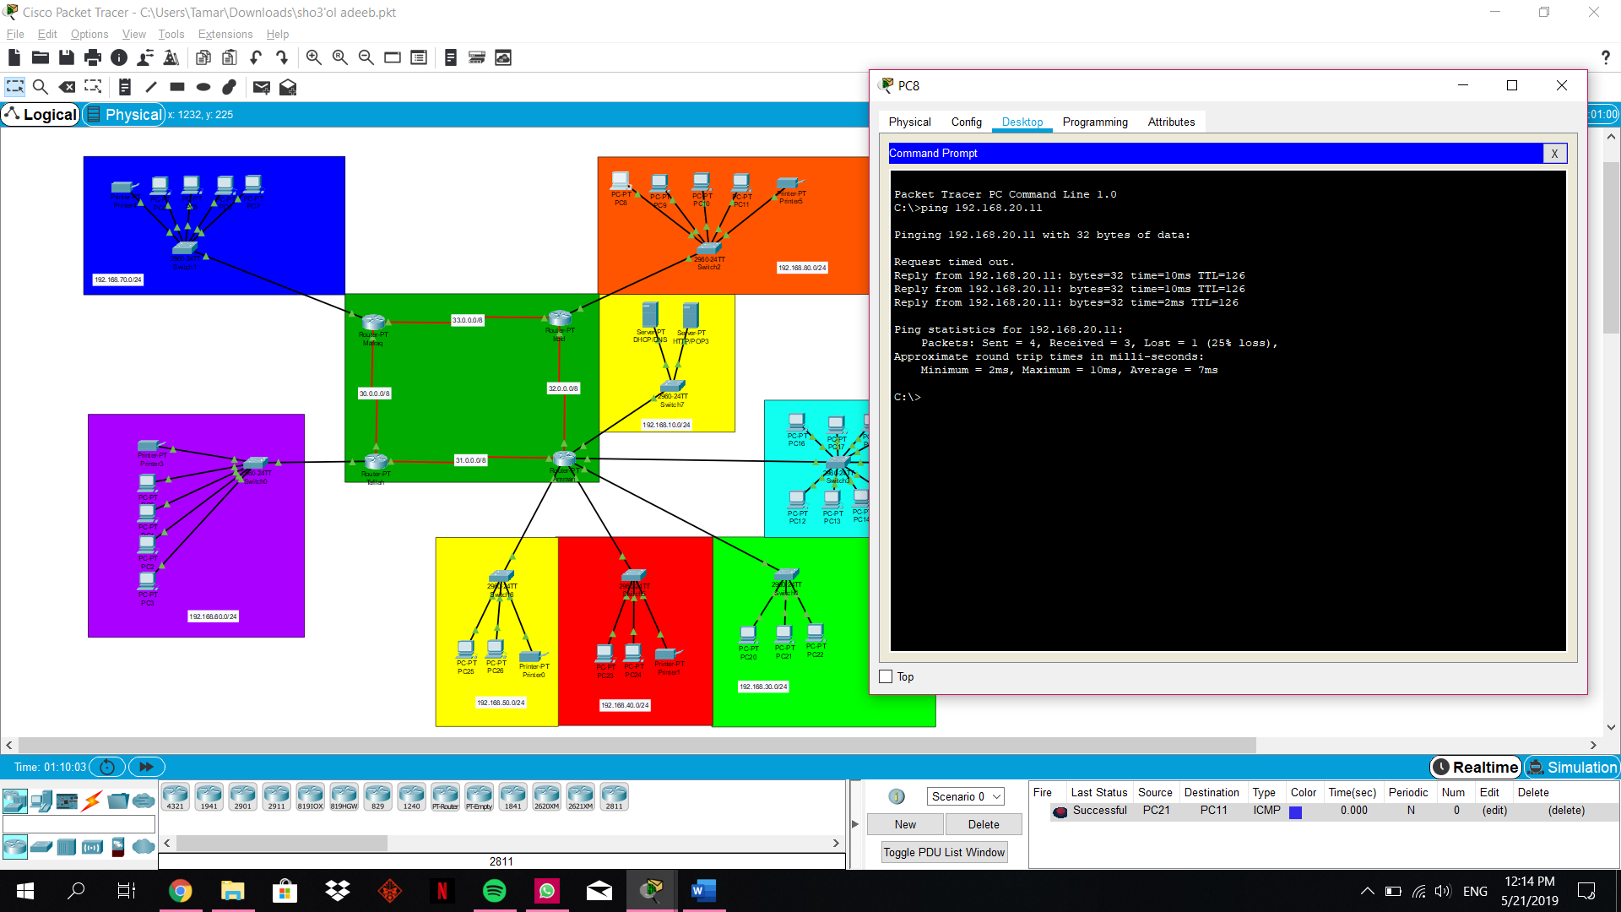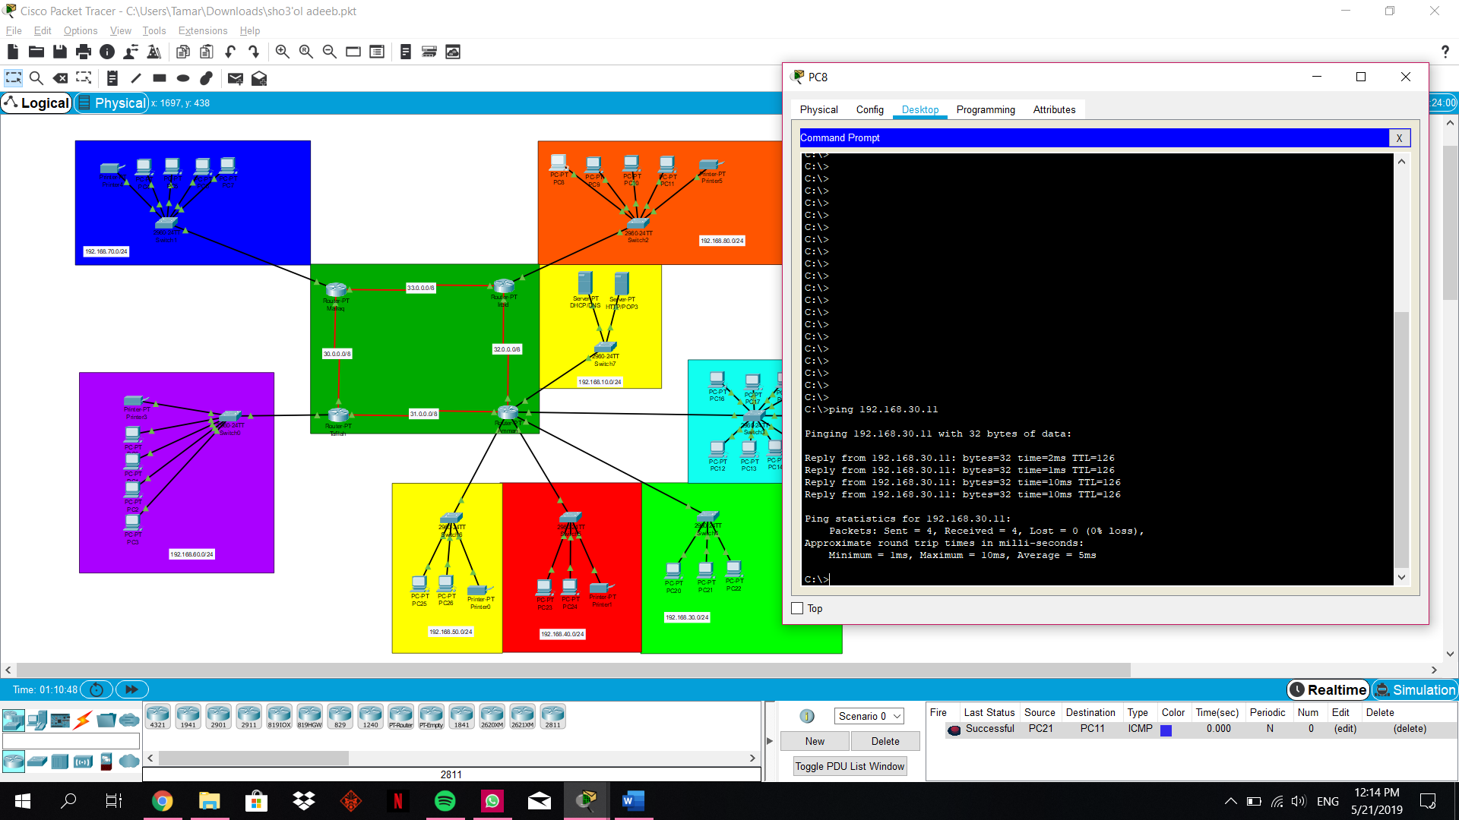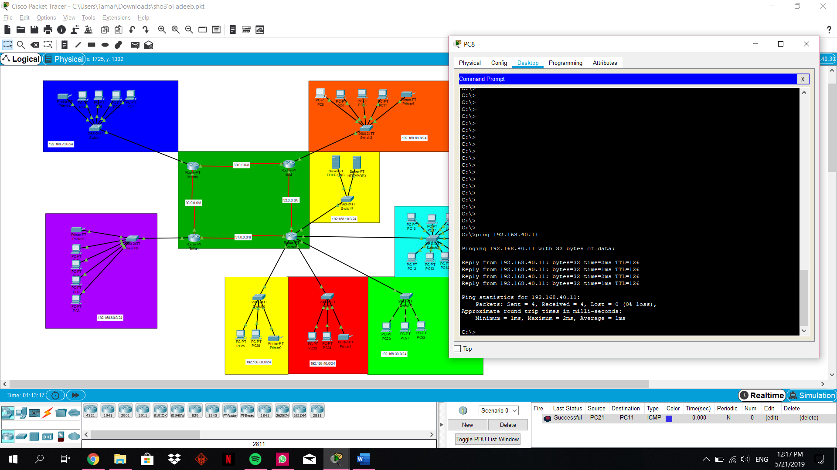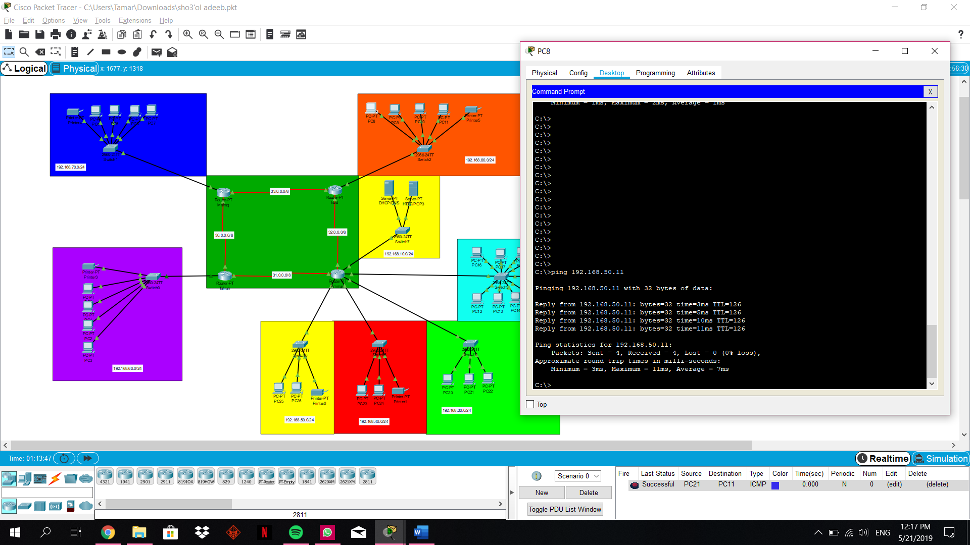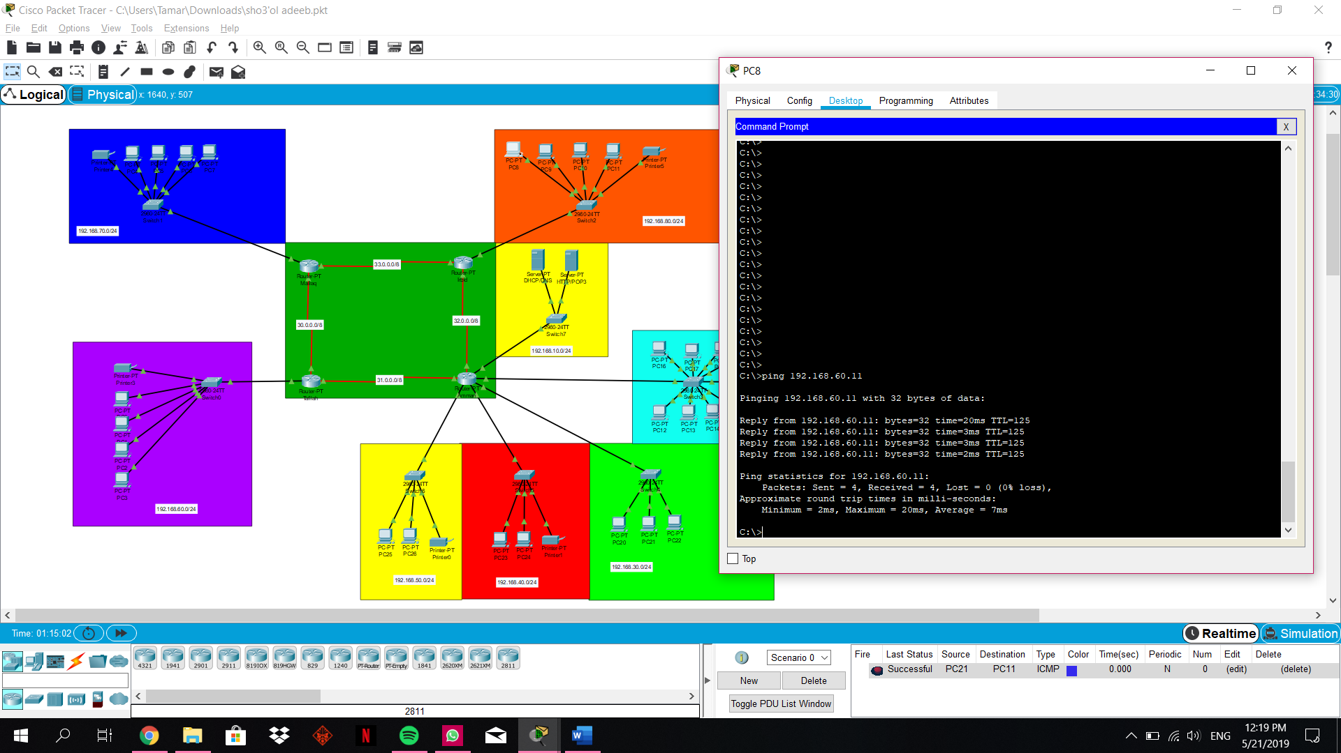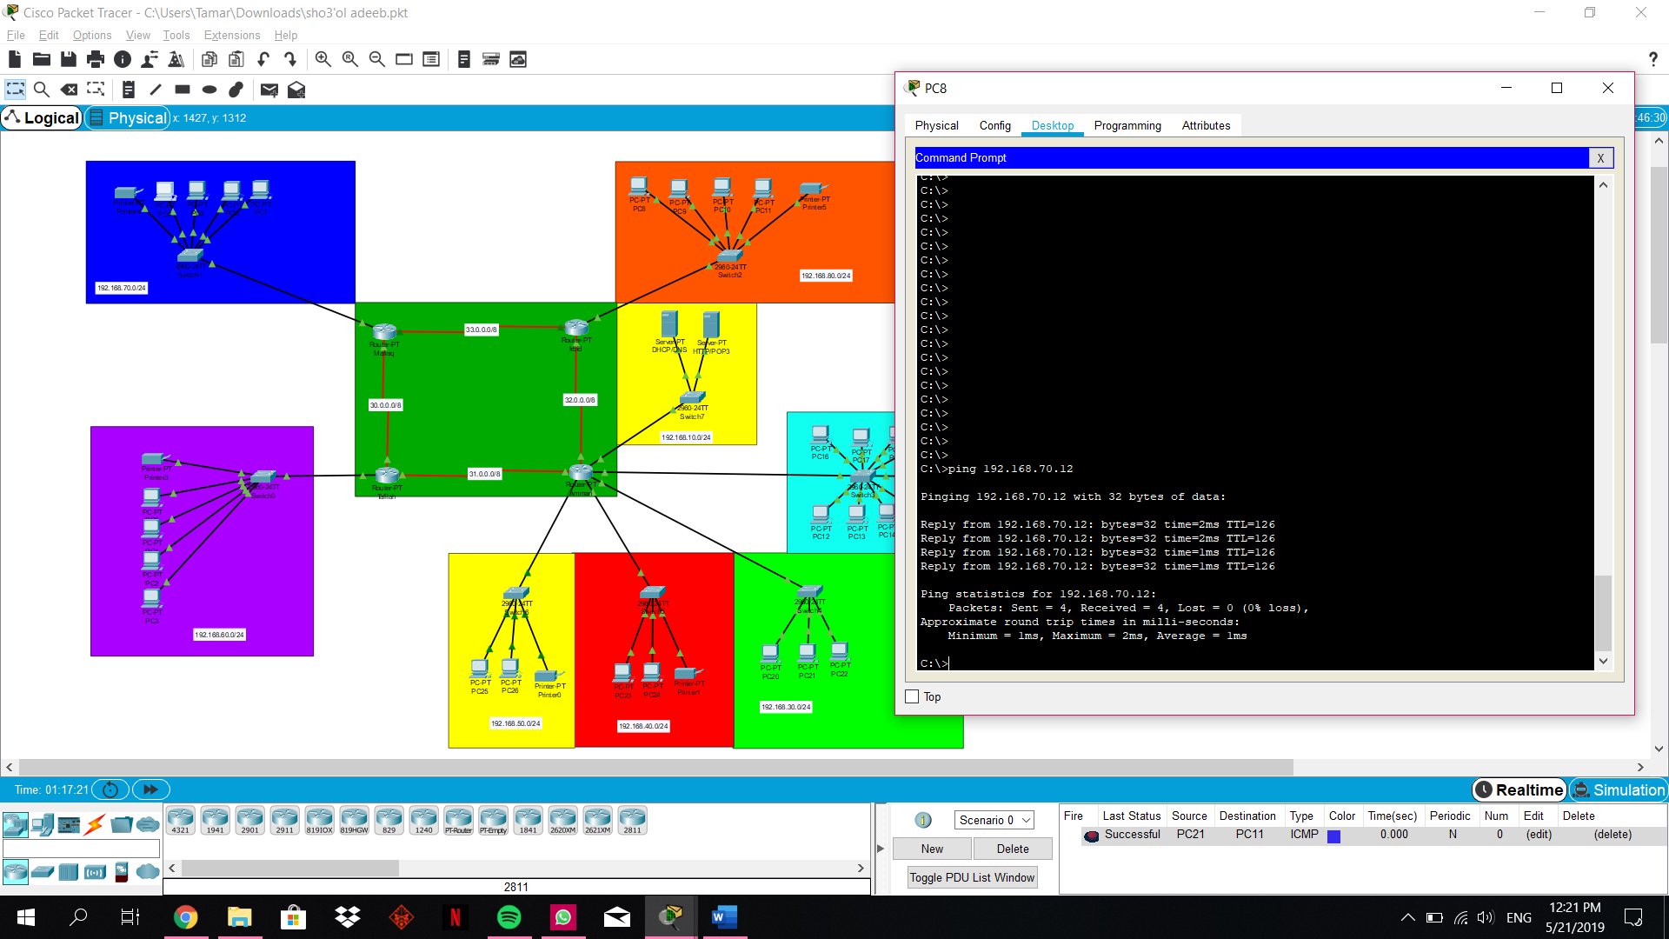

**DHCP:**

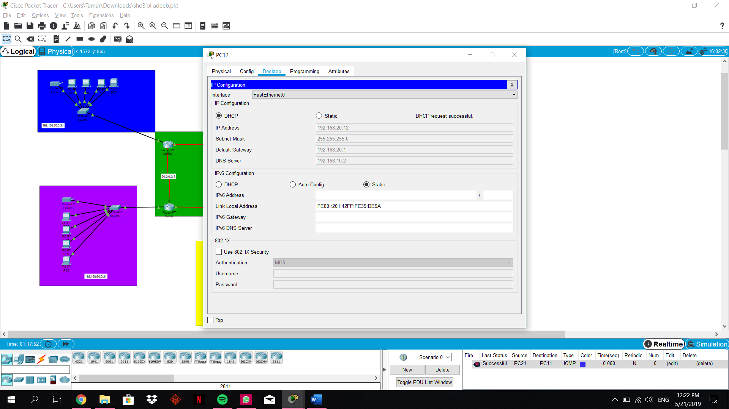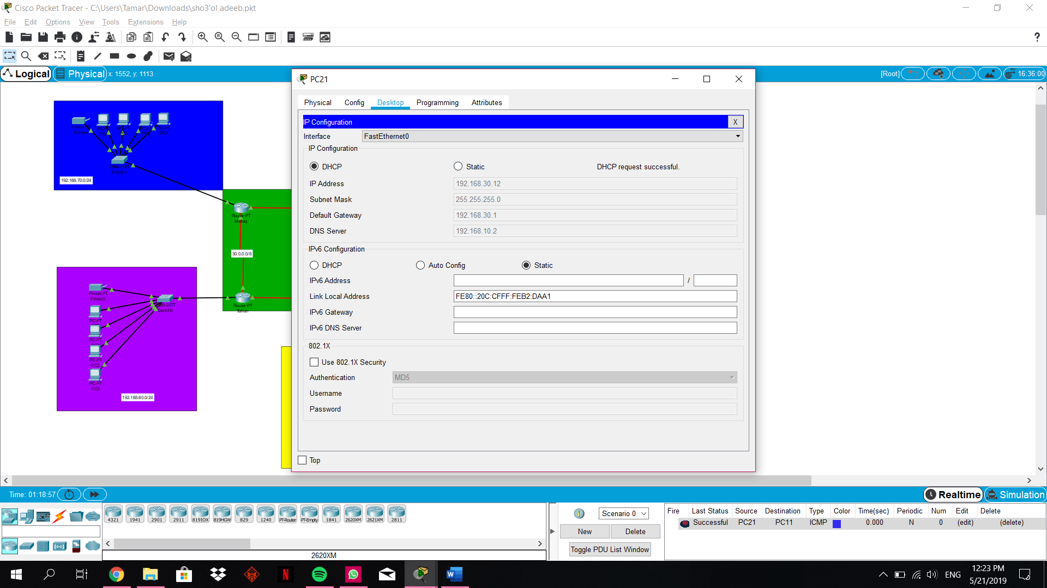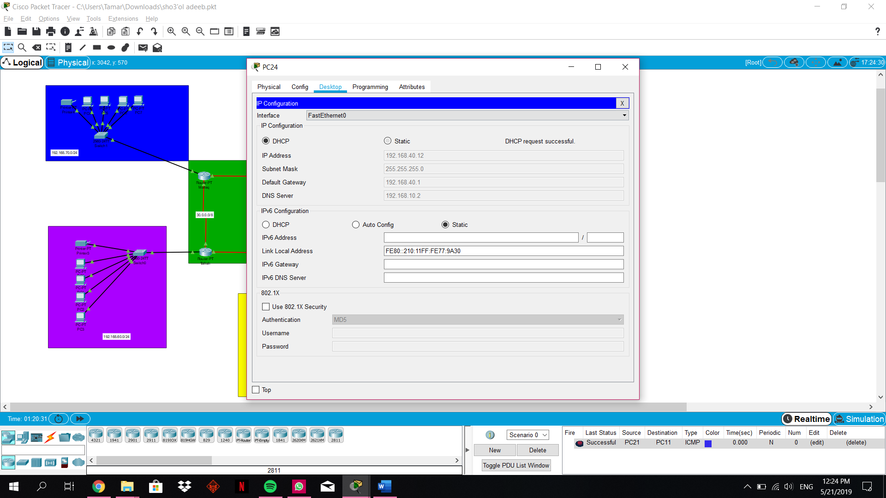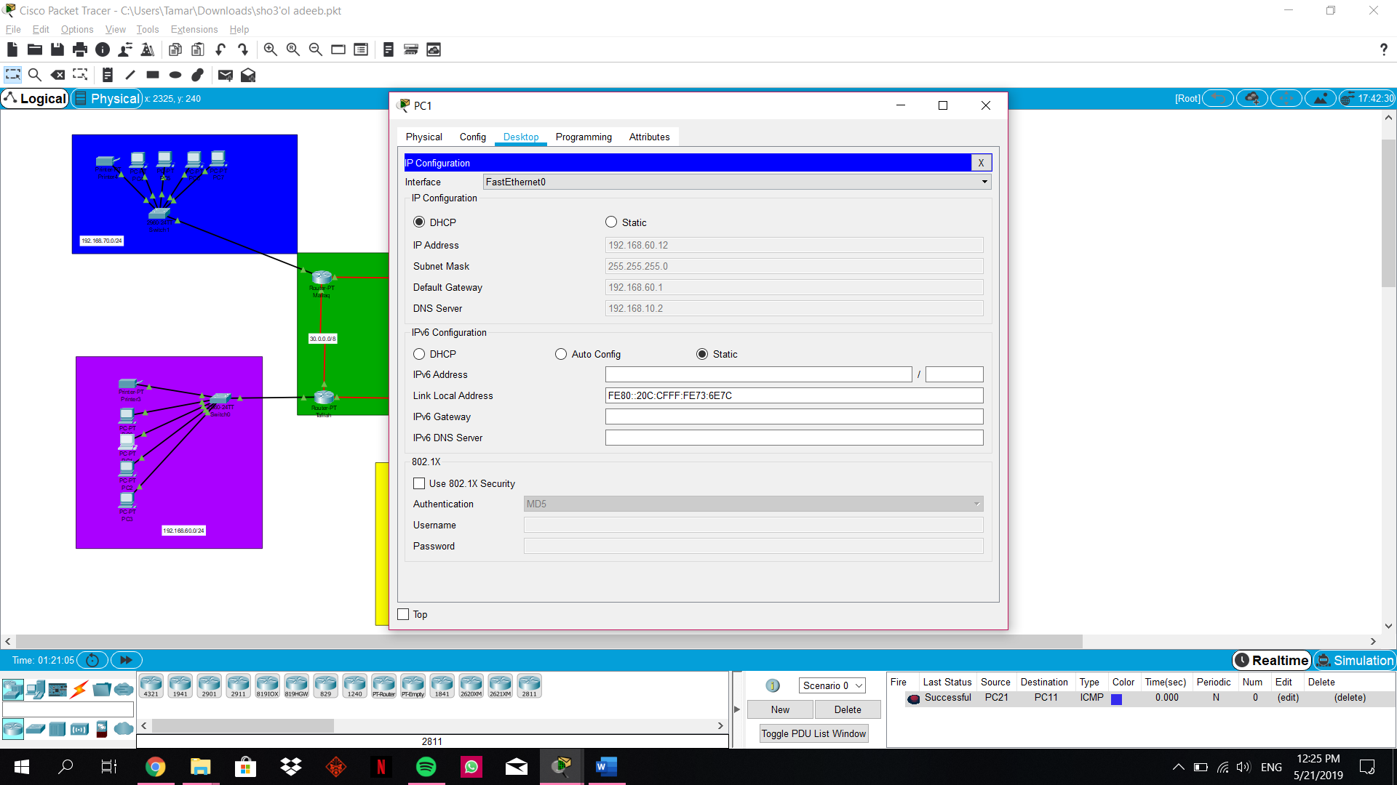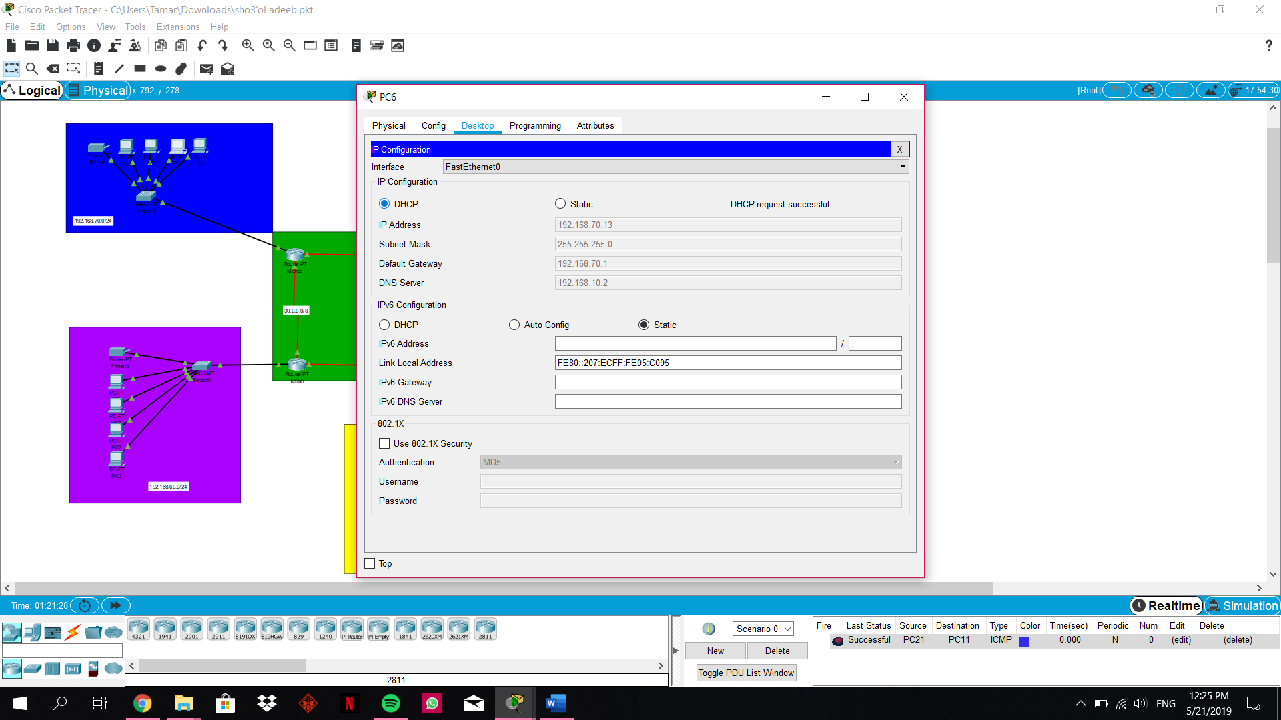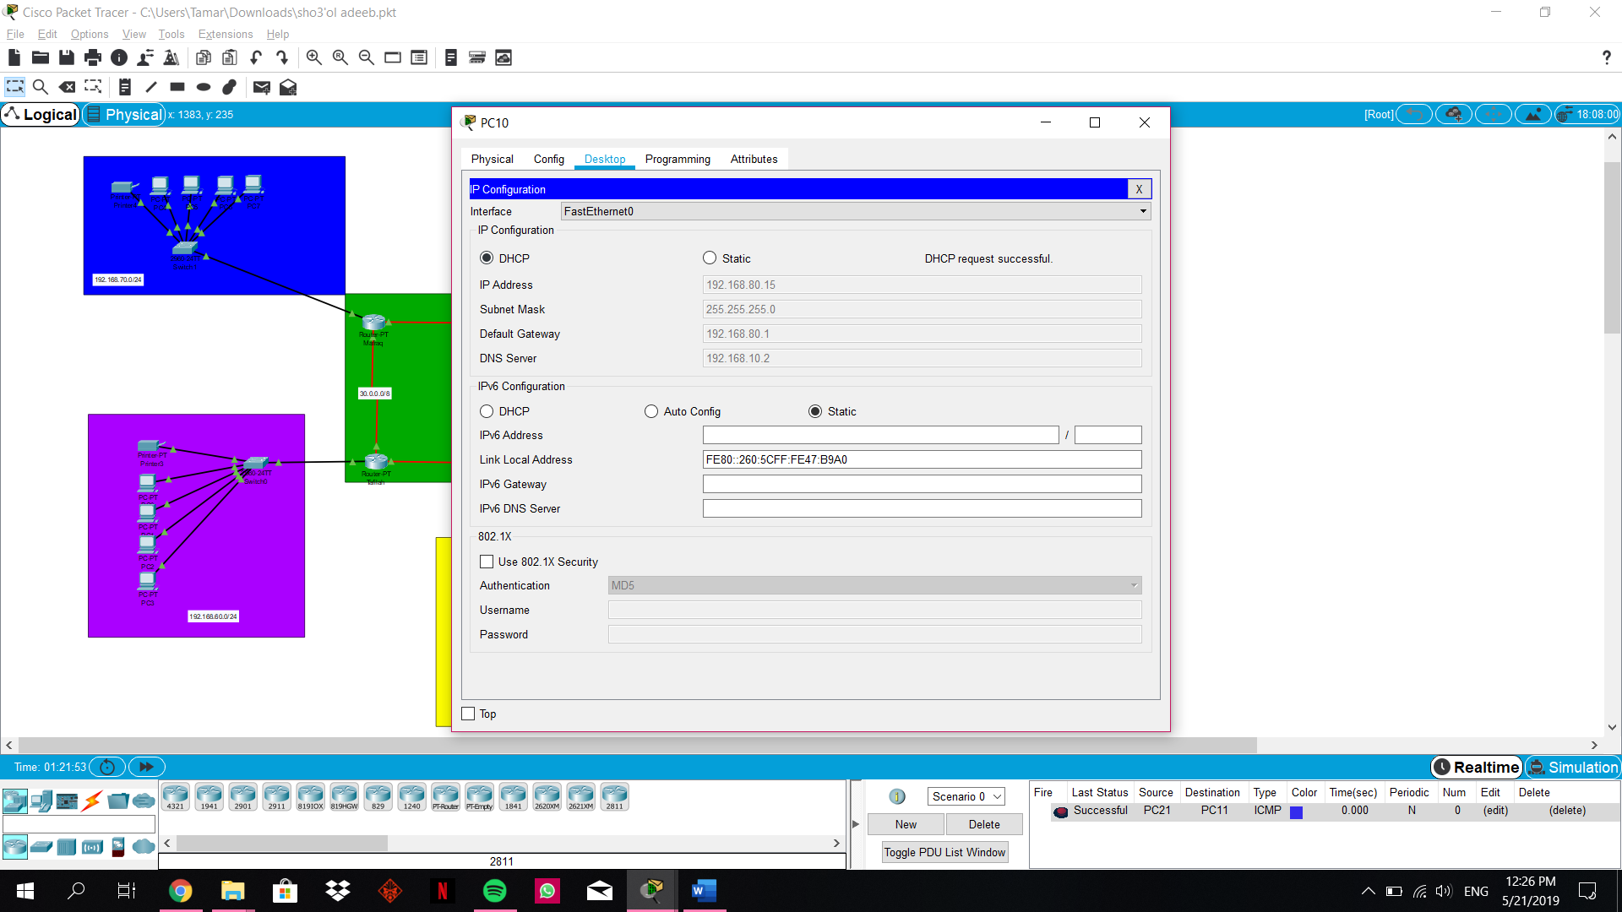

**HTTP:**

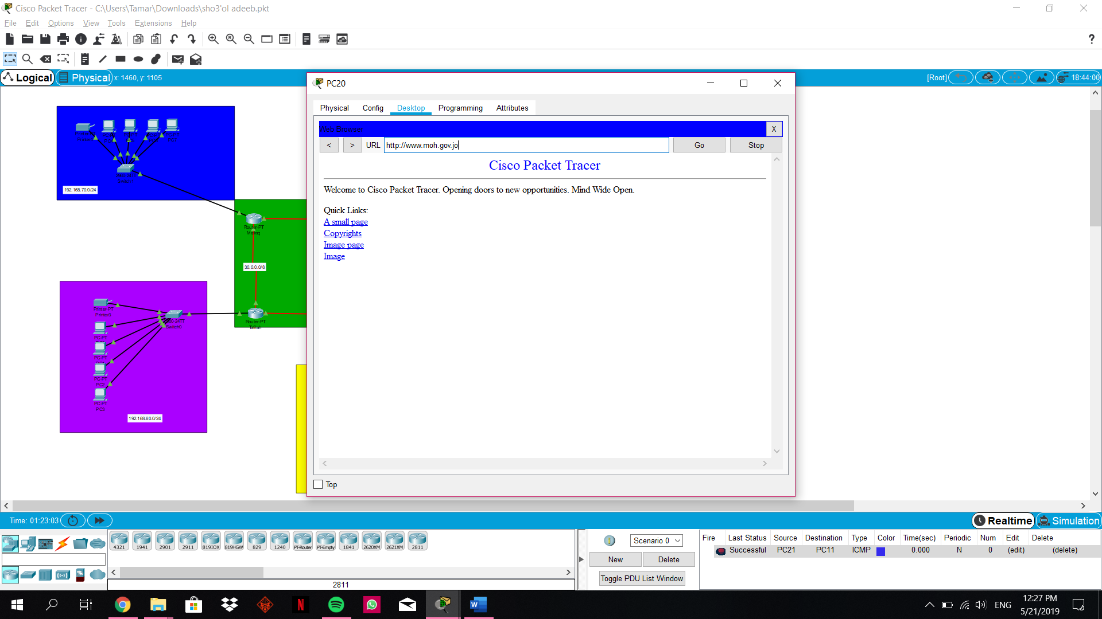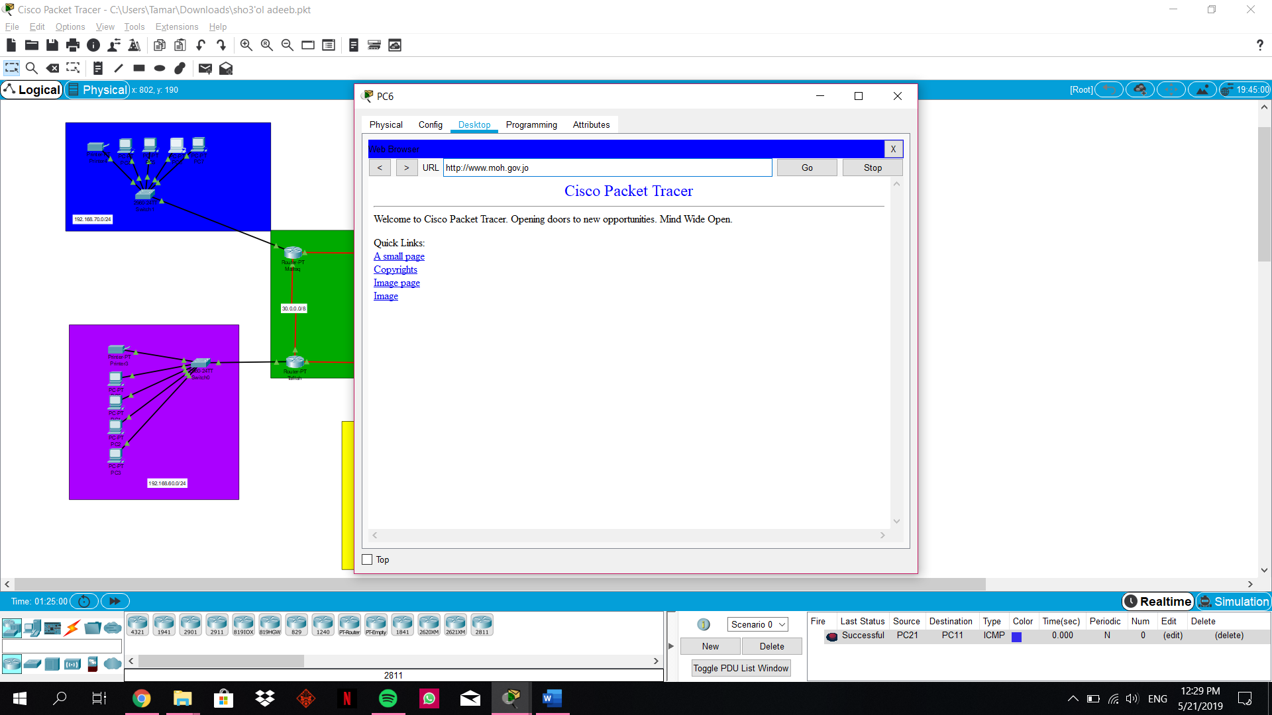

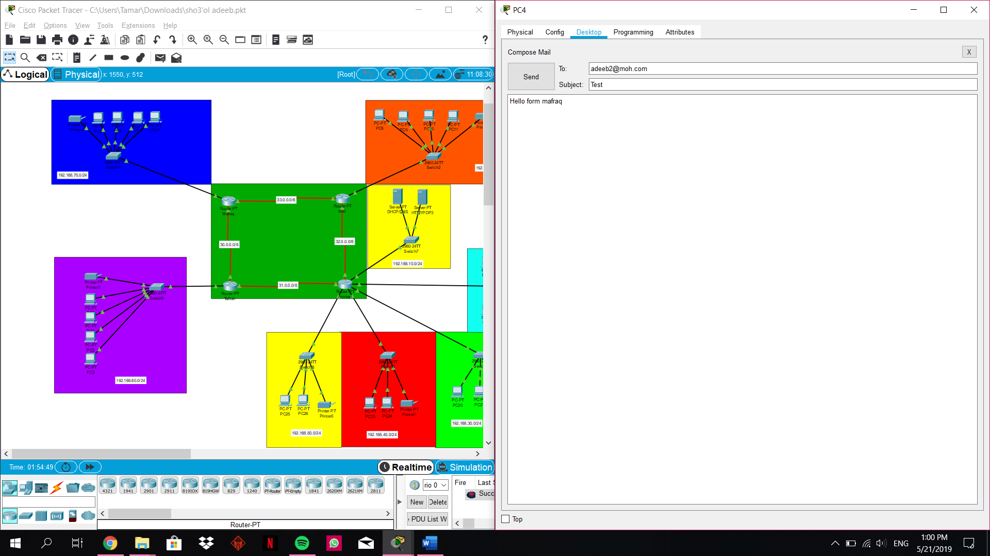

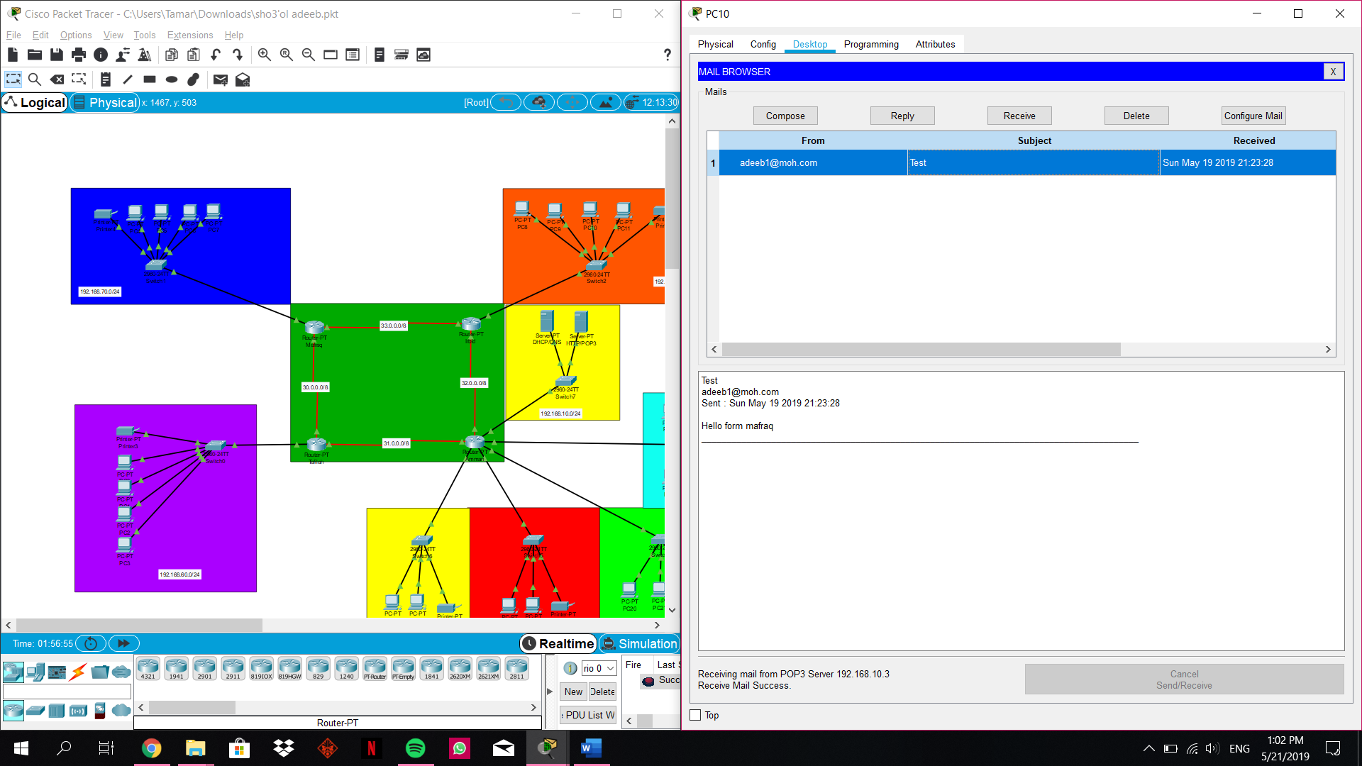

After screenshotting, we should expect that when we ping Amman to Tafilah or Mafriq to Amman, etcc… the rest of the computers should reply and respond that it has succeeded.

Also DHCP should automatically accept the request because the computers had ping.

And for the web browser checking we should match the URL in the DNS we chose with the URL we are trying to check. Finally we need to check if every computer can send and receive emails from different governorates and I expected they should receive the emails that’s sent and actually it worked.

Now, I recommend some upgrades for our network system, one of the upgrades is to upgrade from ADSL to Fiber because ADSL uses telephone lines so it transmits data using copper cables from the nearest telephone exchange to the office. But copper cables can be affected by bottlenecks, so the download speed will be slow if there was more internet traffic.

And Fiber uses optic cables to transmit data so the data can travel in a very high speed and distance doesn’t affect the exchange of data. Fiber can handle more traffic without affecting the download speed. So we can use this upgrade to increase speed and steadiness.1

Also, we can upgrade the connection of the routers using wireless connection instead of Cerial cables so we can increase the reachability. One of the more important upgrades is for example: computer’s operating system is windows Vista; we can upgrade them to windows 10 to make the operating system easier and more secured and it’s the best option for businesses to keep the data more secured and safe.

In the security, we can use the firewall to increase the security, for example; we can use the Fortinet | NextGen network firewall device: it’s one of the best firewall for the network security for small and large network types. This firewall gives multi wan port to use load balance for the network and its useful when you use the multi internet connection to use failover with zero downtime.2

In my opinion, if I had had to redo the network system project, I would have made more improvement to the system such as; adding more security (add more VPN for example) or I could add more servers to the system like the FTP server so we can share more amount of files or data. And I also would make a direct connection between Amman and Mafraq so if one of the serial cables are down or have traffic.

**References: (not all the paragraph are from the websites)**

**1-** RSAWEB. 2019. Fibre vs ADSL: The difference in speeds | RSAWEB. [ONLINE] Available at: <https://www.rsaweb.co.za/fibre-vs-adsl-the-difference-in-speeds/>. [Accessed 20 May 2019].

**2-** TechTricksZone.com. 2019. The 10 Best Firewall Security for Home and Office Networks (2018). [ONLINE] Available at: <https://techtrickszone.com/2018/02/10/10-best-firewalls-solutions-home-office-network-2018/>. [Accessed 20 May 2019].